This Remote Outfitting Package has been created to enhance our ability to provide appropriate sizes of equipment to clients throughout Southern Alberta.

Calgary Flames Sports Bank is committed to doing the best job we can at finding the proper fit of equipment to ensure the safety of each child. By properly measuring your child you are doing your part in making sure your child is safe when taking part in their chosen sport(s). A remote outfitting package is to be completed for every family requesting equipment that is not able to make it into the shop for a proper outfitting. Below you will find a description on how to best complete the measurements of your child. Each child requesting equipment will need to fill in a remote outfitting package. These measurements are meant to be comprehensive and help us outfit for almost every sport. However, we may require additional measurements depending on your request.
In this package you will find:
- Measurement instructions (page 2)
- A blank measurement form (page 4)
- A foot tracing page (page 5)
- A hand tracing page (page 6)
Different sports require different measurements. Please refer to the Equipment Measurement Legend to find out what measurements are required for your request.
A soft tape measure is best to use to take these measurements. If you do not have one they can be purchased at most dollar stores.

Measurement Instructions
Measure in inches and pounds unless otherwise indicated.

Age
Age helps contribute to equipment selection, but more specific measurements are needed.
Armpit Height
Measure from the child’s armpit straight down to the floor.
Bicep Circumference
Measure all the way around the middle of the child’s bicep.
Chest Circumference
Measure around the middle of the child’s chest.
Elbow Length
Measure from the middle of your bicep to the middle of your forearm with the child’s elbow at 90-degrees.
Floor to Bent Arm Height
Have the child hold their arm at a 90-degree angle and measure the distance from their underarm to the floor.

Floor to Wrist Height
Have the child stand straight with their hands down by their side. Measure from their wrist straight down to the floor.
Foot Size
Trace the child’s left foot on the provided sheet. Ensure the child is wearing a sock and has this sock pulled tight.
Head Circumference
Measure the child's head circumference (all the way around), just above the eyebrows, behind the top of the ears and over the large 'bump' at the back of the skull. Pull the tape measure gently snug, but not tight.

Height
Have the child stand up straight against a wall and measure from the floor to the top of their head.
Inseam
Measure from the child’s groin, straight down the inside of their leg, to the floor.

Left/Right
This does not refer to whether your child is left or right handed. Many athletes’ dominant playing hand is opposite of their writing hand. Please indicate the child’s preference for each applicable sport.
Leg Length
Measure from the center of the child’s hips down the leg to the top of the ankle bone.
Mid-Thigh Length
Measure from the middle of the thigh down the leg to the top of the ankle bone.
Nose Height
Measure the length from the bottom of the child’s nose straight down to the ground.
Overhead Wrist Length
Have the child stand straight with one arm raised straight up in the air above the child’s head. Measure from their wrist straight down to the floor.
Shin Length
Measure from the middle of the knee to the top of the ankle bone.

Shoe Size
Indicate your child’s US shoe size.
Shoulder Width
Measure from the tip of the child’s shoulder along their back to the tip of their other shoulder.
Thigh Length
Measure the distance from the middle of the child’s hipbone to the center of the child’s knee.
Torso Length
Measure from the base of your neck straight downwards to right above where the hip bones start.
Waist Circumference
Measure the distance around the center of your hips.
Weight
Indicate the child’s weight in pounds.
Width of Hand
Measure the circumference of the child’s hand at the widest part (usually their knuckles).
Wingspan
Have the child hold their arms straight out at a 90-degree angle from your body and measure from wrist to wrist.
Measurements

Child’s Name: _________________________________________________________
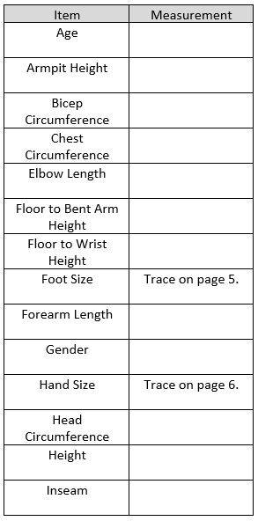
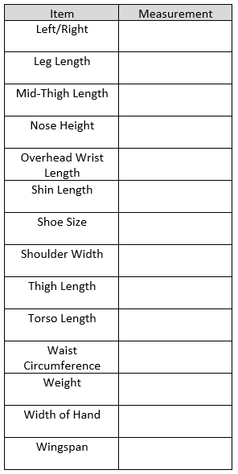

Foot Tracing
Hand Tracing

